NAME: ______________________________EMAIL: _____________________________
Sign up here to receive occasional emails from Flippin’ Pizza about announcements, promotions or special offers.

Voted
BEST PIZZA IN DC!
2009 Washingtonian.com Pizza Poll
Help earn some dough for…
The JEB Stuart High School Crew Team
FUNDRAISER
Thursday, March 7, 14, 21, 28
4:00 PM TO 9:00 PM
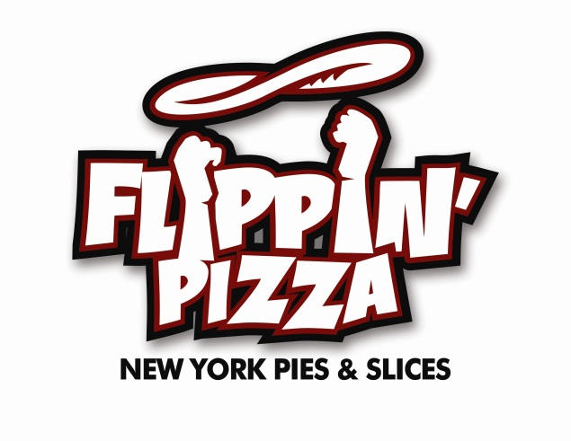
You Must Bring
This Flyer with
You to Flippin’ Pizza
For Group to
Earn Credit
You Must Bring
This Flyer with
You to Flippin’ Pizza
For Group to
Earn Credit
Annandale
6544 Little River turnpike Annandale VA 22312
(703) 752-9912
(Located in Pinecrest Shopping Center)
Support the crew team by eating at Flippin’ Pizza in Annandale on Thursday, March 7, 14, 21, or 28, anytime between 4:00 and 9:00 PM. Flippin’ Pizza will donate 50% of sales (generated by those who bring a flyer during this time) to the crew team. You must bring this flyer with you for the team to earn credit. Feel free to call ahead and order take out or dine in. Sorry, delivery orders are not eligible for the fundraiser.
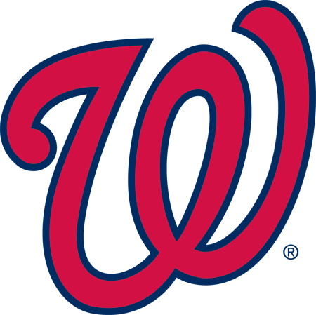
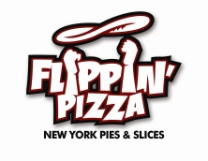
www.flippinpizza.com
OFFICIAL PIZZA OF THE WASHINGTON NATIONALS

